Yunlu Li

STAT 5120

Homework 9

1. (a) Logistic regression is appropriate because log odds and log dose seem to have linear relationship.

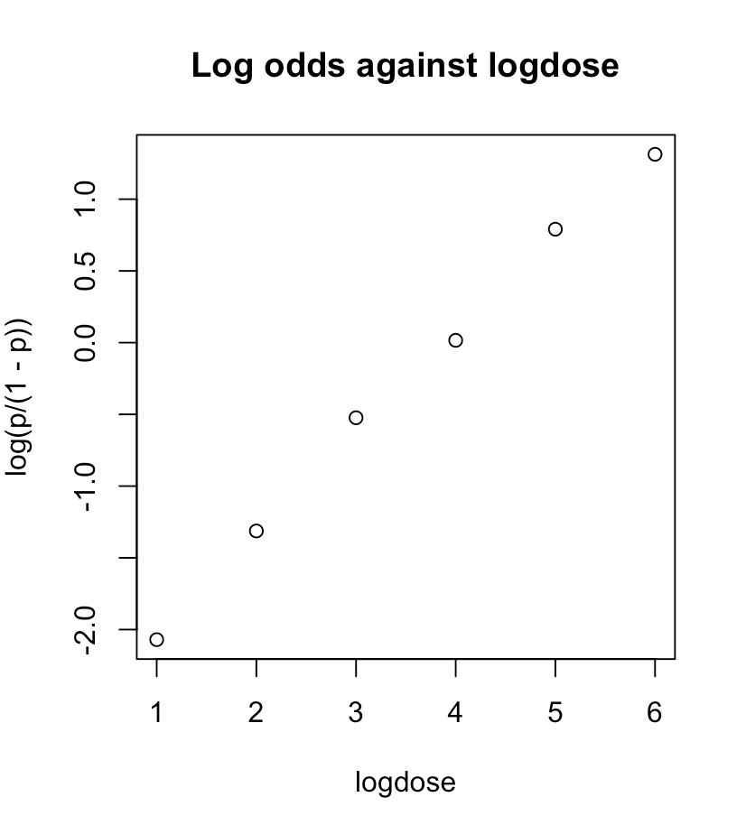

(b) $\log\left(\frac{π}{1-π}\right)=-2.64367+0.67399*logdose$

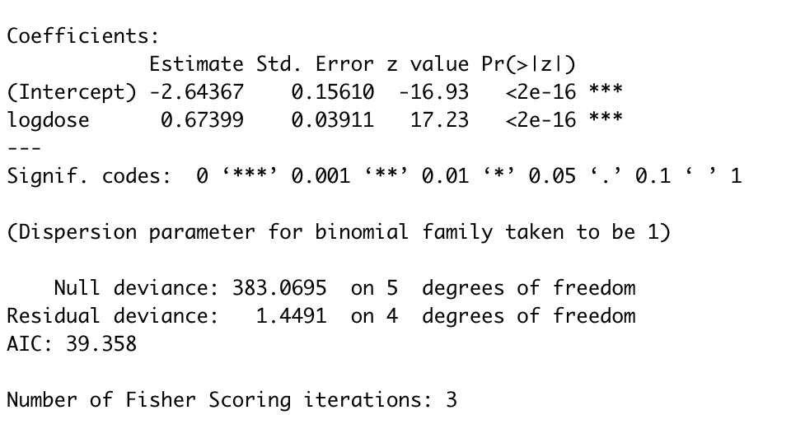

(c) The estimated log odds of death increases by 0.67399 if log dose level increases by 1.

(d) estimated odds ${=e}^{-2.64367+0.67399*2}=0.2737$ 1

(e) $π =\frac{e^{-2.64367+0.67399*2}}{\left[1+ e^{-2.64367+0.67399*2} \right]}=0.21489$

(f) $0.27371*e^{0.67399}=0.53703$

(g) 95% CI $=0.67399±1.96*0.03911=(0.5973344, 0.7506456)$

By exponentiating the limits of CI, we have (1.81726822823, 2.1183671931).

We are 95% confident that odds of death increases by a multiplicative factor with values between 1.81726822823 and 2.1183671931 if log dose level increases by 1.

(h) H0: Our model is reasonably adequate; Ha: Our model does not fit data well.

Using Pearson’s test, we have X2= 1.451786. The associated p-value is 0.8351462, so we cannot reject the null. We conclude our model is reasonably adequate.

Using deviance goodness, we have G2=1.4491. The associated p-value is 0.8356191, so we cannot reject the null. We conclude our model is reasonably adequate.

2. (a) The estimated log odds of a client ever receiving a flu shot for males is 0.43397 higher than for females, for given age and health awareness.

(b) Z = 0.43397/0.52179 = 0.83169. The p-value is 0.40540 > 0.05, so we cannot reject the null. We conclude that gender is not significant in predicting the probability of getting

a flu shot, for given age and health awareness.

(c) $H_{0}: β_{1}=β_{3}=0$; $H_{a}:$ at least one of $β_{1}$ and $β_{3}$ is non zero.

Test statistics: $∆G^{2}=113.2-105.09=8.11$

The associated p-value is 0.01733548. which is less than 0.05. Thus, we reject the null.

We conclude that we cannot drop both age and gender from the model.